Assignment – 4
A* Algorithm for an application

Problem Statement:
The A* algorithm is one of the most popular search algorithms used in pathfinding and graph traversal. It aims to find the shortest path between a start node and a goal node in a graph, using a heuristic function to guide the search. The goal of this assignment is to implement the A* algorithm for a specific application—such as finding the shortest path in a maze, a map, or a grid-based environment.

Software used:
- Python 3.x
- Google Colab

Libraries and packages used:
- NumPy: For representing the grid or graph as a matrix
- Heapq: For efficiently managing the priority queue used by the A* algorithm
- Matplotlib (optional): To visualize the grid or pathfinding process
- NetworkX (optional): For representing more complex graphs

Theory:
The A* algorithm is an informed search algorithm that efficiently finds the shortest path between two points. It combines features of both Dijkstra’s Algorithm and Greedy Best-First Search by using a heuristic to guide its search. It uses a heuristic to estimate the cost to reach the goal and combines this with the actual cost to reach a node from the start. The formula for selecting the next node to explore is:
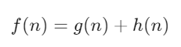
Where:
- g(n) is the cost to reach node n from the start.
- h(n) is the estimated cost from node n to the goal (heuristic).
- f(n) is the total estimated cost from start to goal through node n.
A* always explores the node with the lowest f(n) value, which makes it an efficient algorithm for finding the shortest path in both grids and graphs.

Methodology:
- Define the Graph or Grid: Represent the environment where pathfinding is needed. For example, use a 2D grid where some cells are obstacles, and others are passable.
- Initialize Data Structures:
- A priority queue to store nodes to explore, prioritized by their f(n) values.
- A list of visited nodes to avoid re-exploring nodes.
- A dictionary of parent nodes to reconstruct the path once the goal is reached.
- Heuristic Function: Define a heuristic that estimates the cost to reach the goal. A common heuristic in grid-based environments is the Manhattan distance (for grid maps) or Euclidean distance (for continuous spaces).
- A* Algorithm Implementation:
- Start from the initial node.
- For each node, calculate f(n), where f(n) = g(n) + h(n).
- Explore the neighbours of the current node, updating their costs and adding them to the priority queue if they haven’t been visited.
- Continue exploring the node with the lowest f(n) until the goal is reached.
- Reconstruct the Path: Once the goal is reached, backtrack using the parent nodes to reconstruct the path from the start to the goal.

Advantages:
- Optimal: A* guarantees to find the shortest path if an admissible heuristic is used.
- Efficient: It combines the strengths of Dijkstra’s algorithm (accurate distance calculations) with those of Greedy Best-First Search (speed of heuristic-based exploration).
- Widely Applicable: Used in navigation, robotics, games, and network routing.

Limitations:
- Memory-Intensive: A* stores all visited nodes and frontier nodes, which can be memory-intensive for large search spaces.
- Performance Dependent on Heuristic: The efficiency of A* largely depends on how good the heuristic is. A poorly chosen heuristic can lead to slow performance.

Applications with example:
- Robot Navigation: A* is commonly used in robotics to navigate from one location to another while avoiding obstacles.
- Game AI: A* is widely used in video games to compute paths for characters or agents in grid-based worlds.
Working / Algorithm:
Step 1: Initialize:
- Create a priority queue and add the start node to it.
- Initialize the cost g(n) of the start node as 0 and the heuristic h(n) using the Manhattan distance from the start to the goal.
Step 2: Explore Nodes:
- While the priority queue is not empty:
  - Remove the node with the lowest f(n) from the queue.
  - If this node is the goal, terminate the search and reconstruct the path.
  - For each neighbouring node:
    - If the neighbour is an obstacle, skip it.
    - Compute the tentative cost g(neighbour) and f(neighbour) = g(neighbour) + h(neighbour).
    - If this neighbour hasn’t been visited or if the new path to the neighbour is shorter, update its costs and add it to the priority queue.
Step 3: Reconstruct the Path:
- Once the goal is reached, use the parent pointers to backtrack from the goal to the start, reconstructing the shortest path.

Diagram:
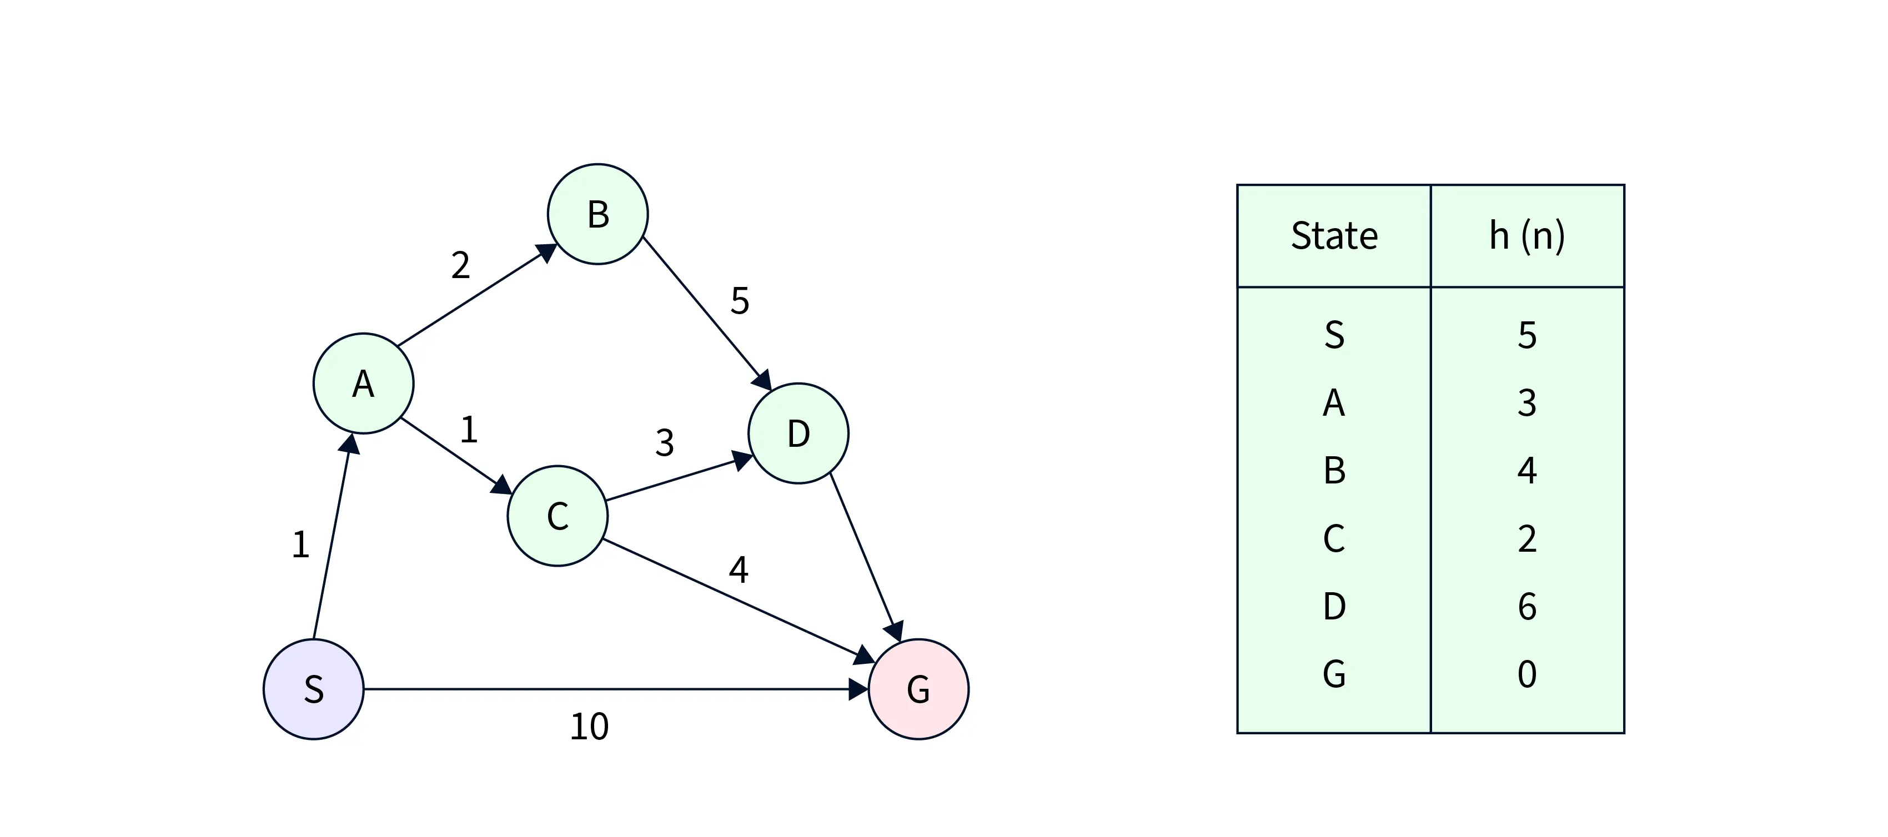

Conclusion:
The A* algorithm is a powerful pathfinding tool that guarantees the shortest path in search spaces where a good heuristic is available. In this assignment, A* can be applied to various scenarios such as grid-based navigation (e.g., maze solving) or more complex environments like maps with weighted edges. Its combination of actual and heuristic cost makes it both optimal and efficient, making it suitable for real-world applications in robotics, gaming, and network routing.

